**Create and manage terms in a term set**

To create and manage terms, you must be a contributor, a group manager, or a term store admin.

To create a term in a term set

1. Open term store management for a site
2. If you need to edit the local taxonomy for a site, you can open the term store management tool from the site.
3. For a site that you own, go to the Site Settings page.
4. Under Site Administration, select Term store management.
   * Select **Add term**.

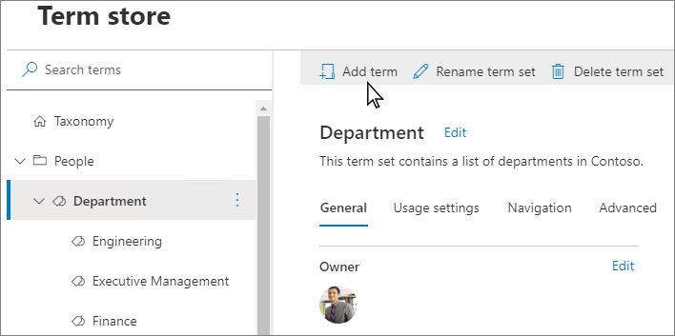

1. Type a name for the term and press ENTER.
2. Update the term settings as needed:
   * On the **General** tab, to add languages, translations, and synonyms, select **Add**. The **Add translation and synonyms** panel appears. Select your language, translation, description, and add synonyms. Select **Save**.
   * On the **Usage settings** tab, to make the term available to the users and content editors of sites consuming this term set, select **Edit**. The **Available for tagging** panel appears. By default, the term is enabled for tagging. To disable, select the **Enable** checkbox. Select **Save**.
   * On the **Advanced** tab, to use shared or local custom properties to store more data about term sets, select **Edit**. The **Edit shared custom properties** panel appears. Add property names and values. Select **Save**.

**Take another action with terms**

There are several actions that you can take on terms that help you build and manage term sets as the business needs of your organization evolve.

To take any of the following actions, first select the term that you want to update.

**Rename term**

* Select **Rename term**.

**Copy term**

* Select **Copy term**. This action shows the name of the new term as **<original term name> - Copy**. No child terms for the source term are copied.

**Copy term with children**

Select **Copy term with children**. This action is only available on terms having at least one child term. This action shows the name of the new term as **<original term name> - Copy**. Children terms of the source term are also copied. Names of children terms are preserved as they are in the source term.

**Move term**

1. Select **Move term**. The **Move to** panel appears.
2. Select the target term set or term.
3. Select **Move**.

**Delete term**

If you delete this term, any terms below it will also be deleted. Terms that are shared with other term sets will be placed in the Orphaned terms set under System.

1. Select **Delete term**.
2. Select **Delete**.

**Pin term**

Pinning a term makes linked copies of the term and its children available at the destination. You can only create or edit the children of a pinned term at the source and the changes reflect everywhere the term is used.

1. Select **Pin term**. The **Pin term to** panel appears.
2. Select the target term set or term where you want to pin the term.
3. Select **Pin**.

**Reuse term**

Reusing a term makes linked copies of the term and its children available at the destination. You can create children for a reused term anywhere it's used but will exist only in the term set they were created.

1. Select **Reuse term**. The **Reuse term to** panel appears.
2. Select the target term set or term where you want to reuse the term.
3. Select the term, and then select **Reuse**.

**Merge term**

Merging this term with another will collapse its synonyms, translations, and custom properties into the other term.

1. Select **Merge term**. The **Merge to** panel appears.
2. Select the target term set or term where you want to merge the term.
3. Select **Merge**.

**Deprecate term**

This action makes any instances of this term in any term set to which it belongs unavailable for tagging. Child terms of the term aren't deprecated.

* Select **Deprecate term**.